**Vitaliy Balanchuk**

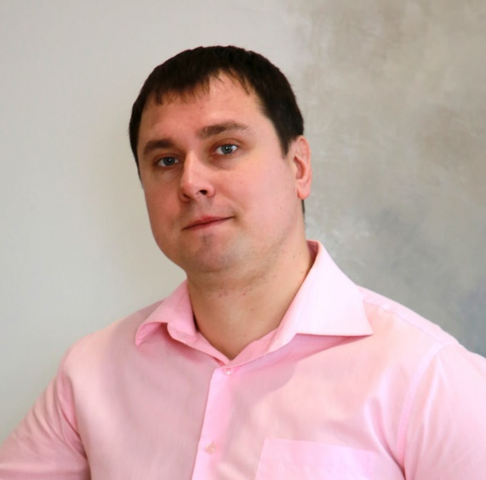 **QA Engineer**

**Contacts**

+30682545493

[Vitalijbalancuk3@gmail.com](mailto:Vitalijbalancuk3@gmail.com)

[Telegram](https://t.me/VitaliyBalanchuk)

[WhatsApp](https://wa.me/+380682545493)

[LinkedIn](https://www.linkedin.com/in/vitaliy-balanchuk-5807a2279/)

Ukraine , Kharkiv region

**Summary**

I am a Junior QA Tester, and I am always eager to learn new things and improve myself. I chose testing as my new career direction because I believe it is useful for society. I am punctual, responsible, and diligent, and these qualities have helped me in every business I have pursued. I am looking for a new team where I can apply my skills, grow with my new company, and contribute towards something meaningful. One of my dreams is to create an environmental project that will help humanity keep our planet clean.

**Technical Skills**

**RDBMS/Database servers**

* SQL server
* MS SQL server
* My SQL

**Operating Systems**

* Microsoft Windows
* Mac OS

**Tools and Technologies**

* HTML/CSS
* Technical Documentation/SRS
* Selenium IDE
* Rest API
* Postman
* My SQL
* Microsoft SQL Server Management Studio
* TestRail
* JIRA
* Git
* JSON
* XML
* Development Tools
* Source Tree
* KDiff3
* Fiddler

**Other**

* SCRUM
* Agile
* Kanban
* Waterfall

**Soft Skill**

* Punctual
* Honest
* Attentive
* Attention to details

**Experience**

Junior Operator Gas Station (OKKO Company) 04/2023 – at this time

* sale of fuel
* sale of related products
* customer service by company standards

Achievements:

* fuel sales have increased by 25%
* receive positive customer reviews

Officer (Armed Forces of Ukraine) 03/2022 -12/2022

* protecting the sovereignty of the country

Achievements:

* promoted to the rank of lieutenant
* receive award for the defense of Kharkiv

Paint Sales Manager (LLC Ceresit; LLC Tikkurila; LLC Element) 08/2008 – 02/2022

* sale of paint and varnish materials
* consultation of customers by technical characteristics of product
* product rendering by RAL, NCS system

Achievements:

* the sales have increased by 40%
* suggestions for improving product quality led to a 60% increase in positive customer reviews
* the brand's customer recognition has increased by 5%

**Education**

**QA Engineer**

Courses on manual testing (Popeliuha)

2024

**QA Engineer**

IT-school GO IT (Kyiv)

2023

**Engineer – Pedagogue**

Ukrainian Engineering Pedagogical Academy (Kharkiv)

2003-2008

**Languages**

**English - intermediate**